PROGRAM 2: CRYPT-ARITHMETIC PROBLEM
Aim
To write a Python program to solve the Crypt-Arithmetic Problem.

Objective
To assign digits to letters so that the arithmetic equation is satisfied.

Algorithm
- Start.
- Assign digits to each letter.
- Check if all letters have unique digits.
- Verify the arithmetic equation.
- If correct, print the solution.
- Stop.

Source Code
S = 9
E = 5
N = 6
D = 7
M = 1
O = 0
R = 8
Y = 2

send = 1000*S + 100*E + 10*N + D
more = 1000*M + 100*O + 10*R + E
money = 10000*M + 1000*O + 100*N + 10*E + Y

print("SEND =", send)
print("MORE =", more)
print("MONEY =", money)

if send + more == money:
print("Solution Verified")

Flowchart
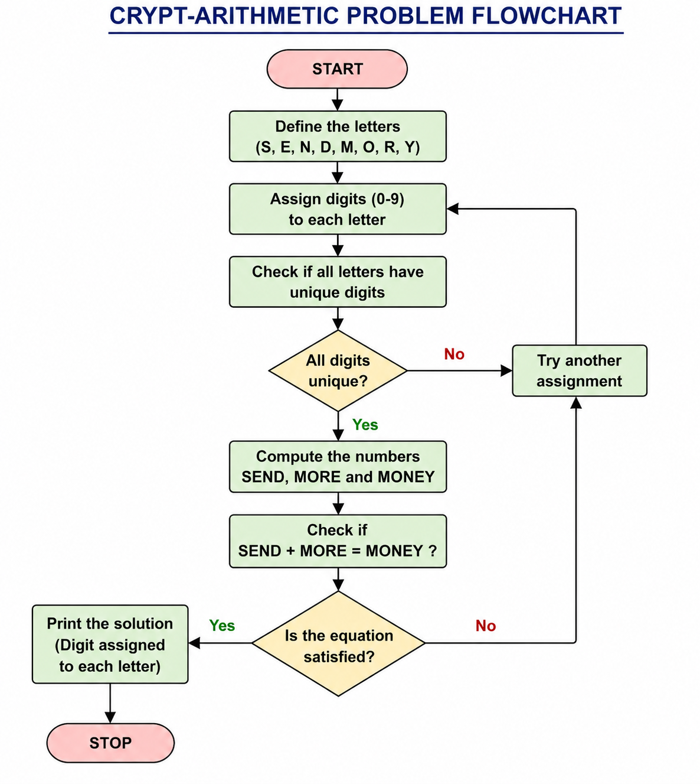

Sample Output
SEND = 9567
MORE = 1085
MONEY = 10652

Solution Verified
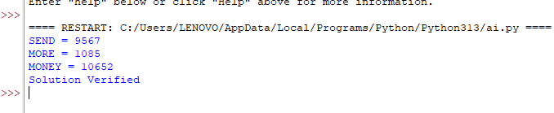
Result
Thus, the Python program for the Crypt-Arithmetic Problem was executed successfully.

